|  |
| --- |
| **HEARTS AFTER GOD LOGO** |

**HEARTS AFTER GOD MINISTRY**

**History about the ministry.**

The ministry, now known as Hearts After God Ministry, commenced its journey on September 19th, 2024. Its genesis was a divine encounter in Western Kenya's Kakamega, where a group of devout Christian friends, sharing a profound spiritual yearning, converged. They sought a space to cultivate their faith through Holy Spirit-led fellowship, prayer, and scripture, unhindered by geographical constraints. This shared desire sparked the concept of an online ministry, leading to the establishment of what initially began as a WhatsApp group.

Over time, the ministry's reach expanded beyond its foundational members, attracting other individuals who resonated with its mission for spiritual enrichment. Our initial activities centered on collective fasting, monthly in-person gatherings, and dedicated prayer and word sessions. Then, on May 21st, 2025, the Lord, through our leader Cyrilla Chikamai, revealed a broader vision: to extend our outreach to new souls through online evangelism and discipleship. This expansion involved leveraging various digital platforms beyond WhatsApp, including blogs, articles, and advertisements, all aimed at raising awareness and carrying forth the ministry's core vision.

**LOCATION AND ADDRESS**

Global online ministry

Available in all socialmedia platforms(.Facebook, Instagram,Tiktok, Telegram,Youtube and Whats app.)

[heartsaftergodministries254@gmail.com](mailto:heartsaftergodministries254@gmail.com)

0707529090

PO.BOX 00100 NAIROBI,KENYA.

**WHO WE ARE**

As an online global ministry, our aim is to advance the gospel and reach out to souls across the universe through digital platforms, complemented by physical missions on the ground. Our main channels for achieving this include evangelism, structured discipleship classes, dedicated prayer sessions, in-depth word study, and fostering real conversations about life situations often overlooked in our generation.

**Mission.**

Our online ministry cultivates an accessible global platform, designed to enable individuals worldwide to forge partnerships, experience profound fellowship, and deepen their intimacy with the Holy Spirit through consistent engagement with scriptural teachings and dedicated prayer*.*

*Acts 2:17*

*And it shall come to pass in the last days says the God, that I’ll pour out my spirit on all flesh, your sons and daughters shall prophesy, your young men shall see visions,your old men shall dream dreams.*

**Vision**

Our fundamental objective is to facilitate the realization of God's divine plans for individuals' lives, empowering them to function fully in His supernatural strength, compassion, and spiritual governance. Through this empowerment, we aim to actively convey and implement God's desires for people globally, thereby drawing an increasing number of human hearts into a relationship with Him.

*Mathew 28:19-20*

*Go therefore and make disciples of all nations, baptizing them in the name of the Father and of the Son and of the Holy Spirit, teaching them to observe all that I have commanded you, and lo, I am with you always to the close of the age.*

**OUR MINISTRY LEADERS**

**MINISTER CYRILLA CHIKAMAI**

One of our Co-founder and leaders of Hearts-after God ministries.

Passionate in driving the ministry's vision to its core goal with the help of other leaders.

**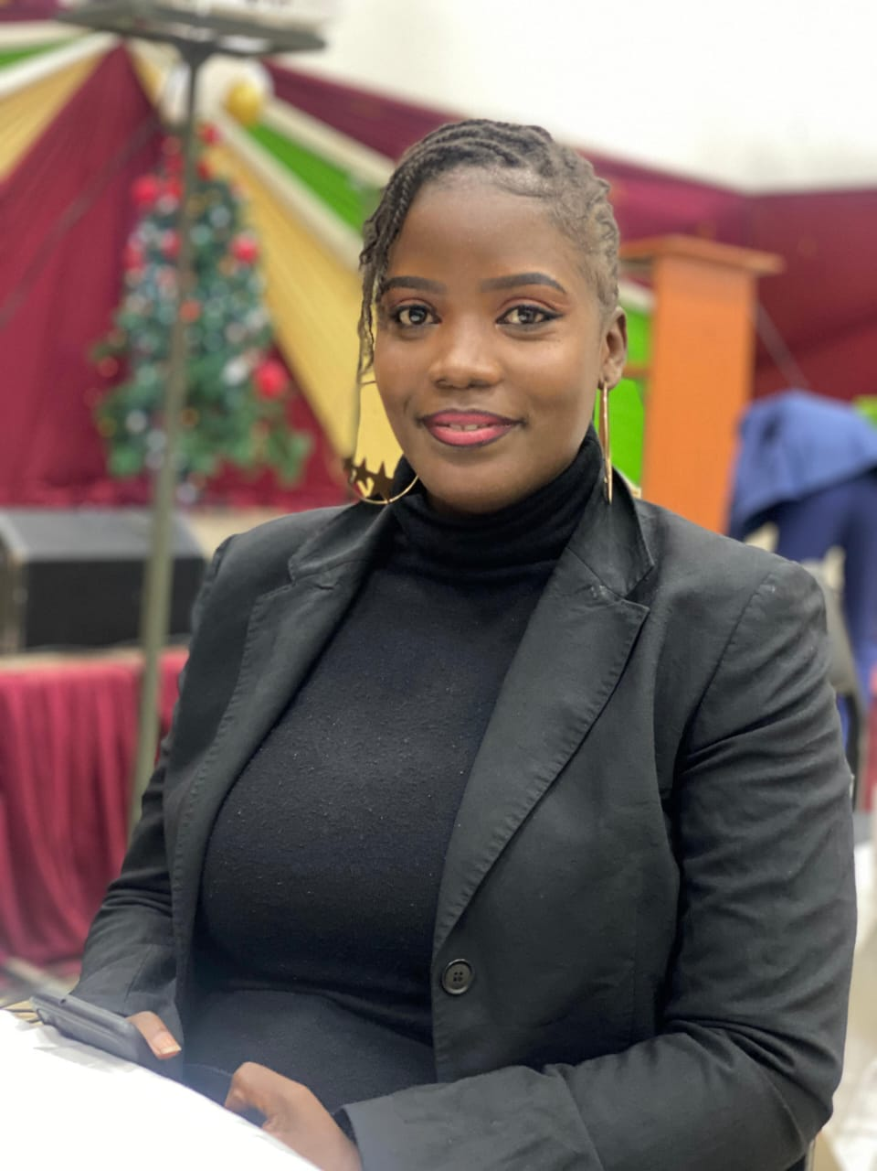**

**MINISTER HUMPHREY MULANDA**

My name is Humphrey Mulanda, a 37-year-old teacher by profession and a passionate pastor and teacher of the Word of God. I love communication and media, mission work, and Christian apologetics. I have a deep calling to mentor youth and teenagers, helping them grow spiritually and navigate life with purpose.

**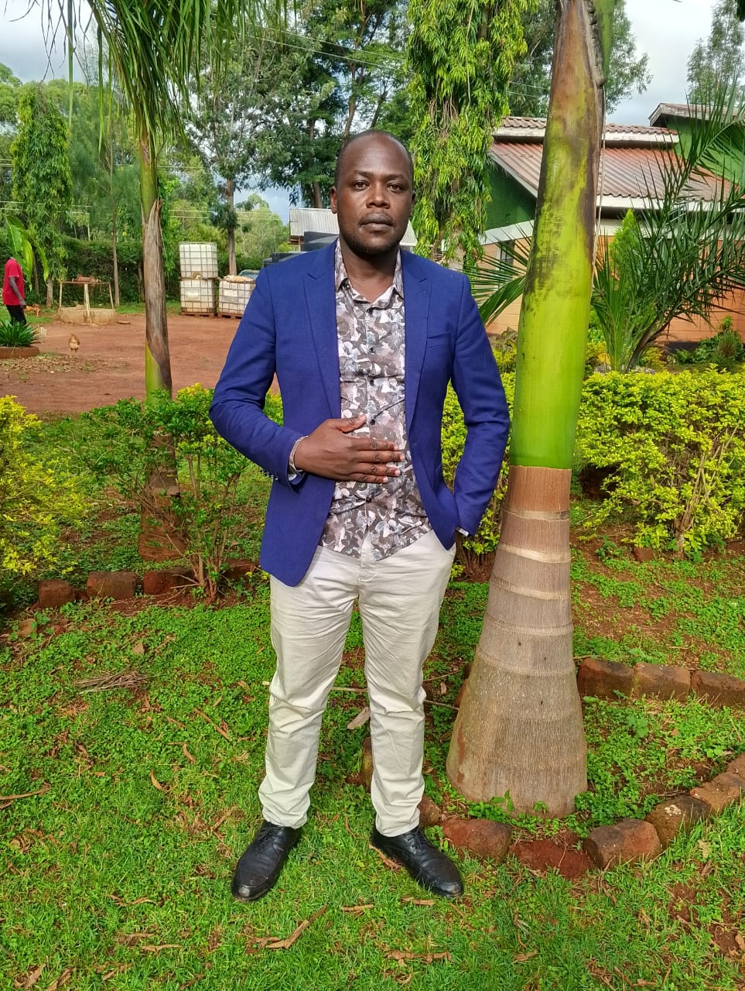**

**MINISTER BONNIFACE ONDUSO**

A man helped by God.Ready to be used by God in the sound and Media department to reach out souls in Kenya, Africa and beyond.

**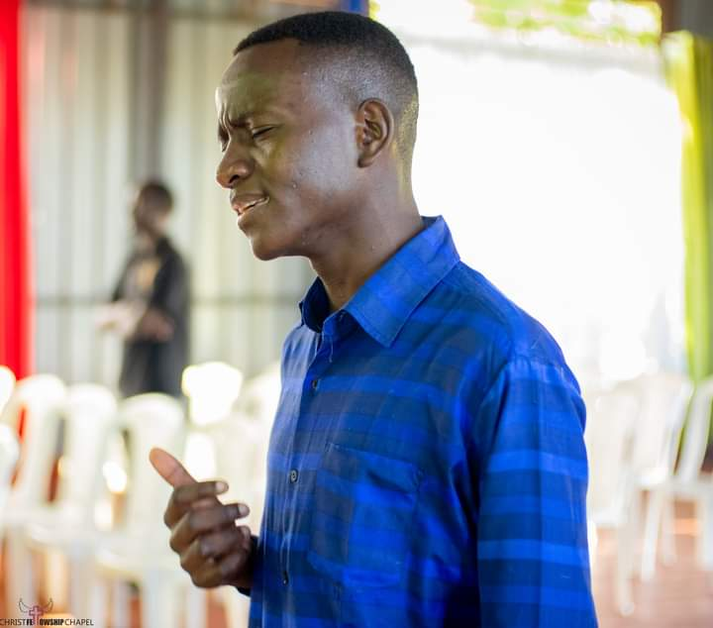**

**MINISTER PALM NAOMI**

I'm Palm Naomi, a passionate young woman with a heart for God, youth, and community transformation. I love serving, mentoring, and encouraging others to pursue their God-given purpose. I believe in walking in purity, love, and truth.

**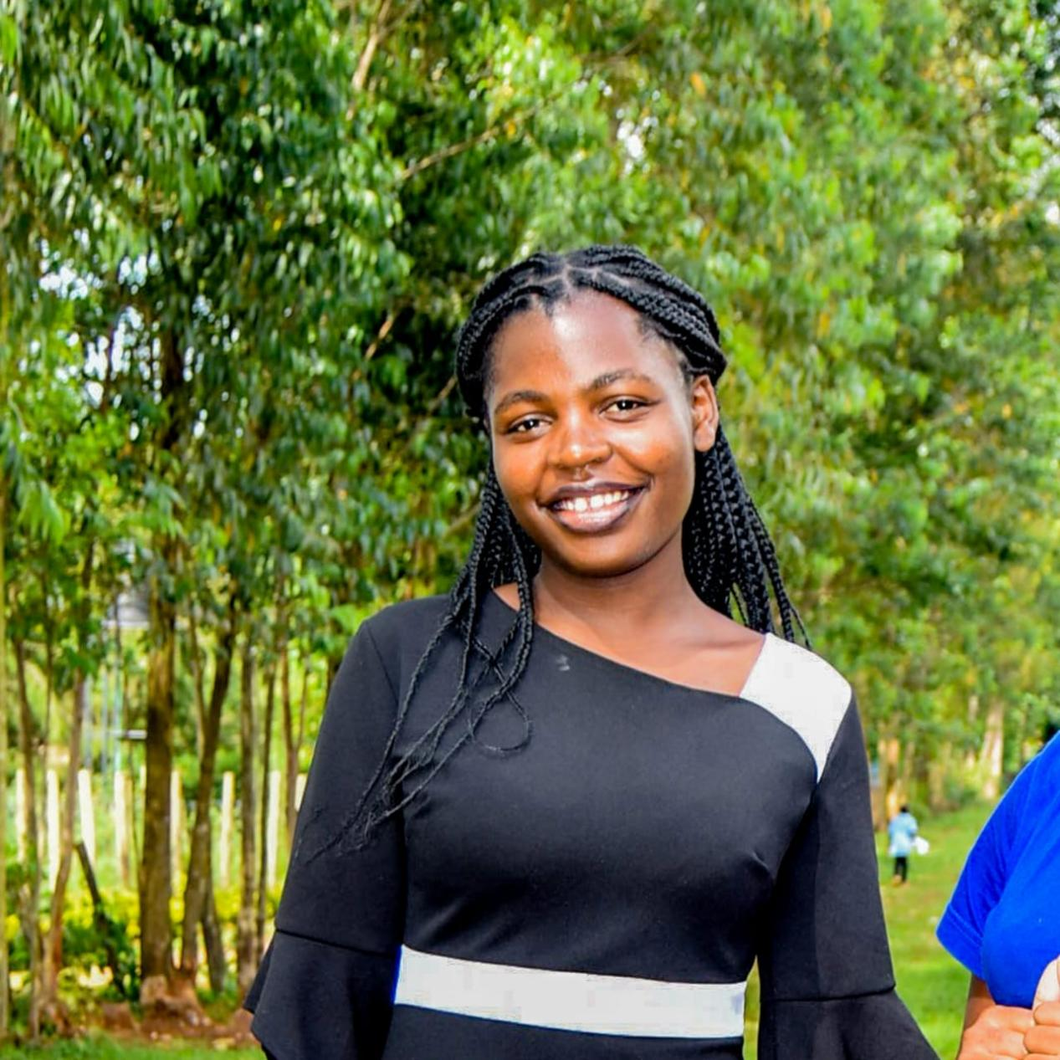**

**MINISTER JOYCE KAKII**

Role vision for ministering to youth and supporting of outreach programmes

****

**MINISTER LUTTAH MUMIA**

Passionate servant of God,”speak My Lord for your servant is listening.”

**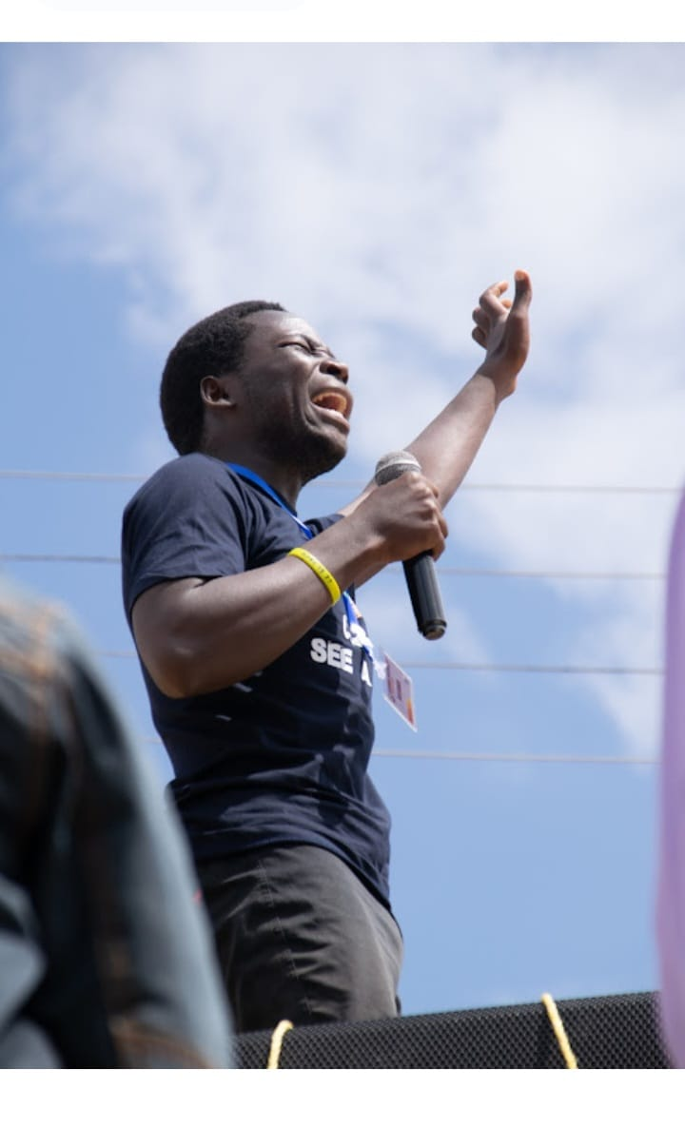**

**Souls Reached**

* To date, this ministry has touched the lives of hundreds, with a notable achievement of three new individuals successfully completing the intensive 14-day Discipleship class led by Minister Cyrilla.
* **Branch Ministries**

From the foundation of Hearts After God Ministry, two distinct branch ministries have emerged:

1. ***Glow for Christ Ministry***

This arm is dedicated to Evangelism, focusing on radiating the light of Jesus Christ through personal lives and actions, thereby positively impacting the world with love, truth, grace, and revival. It encourages sharing personal testimonies with the conviction that *"if I did it, you can do it*!" The guiding scripture for this ministry is **Matthew 5:14-16: "You are the light of the world. A town built on a hill cannot be hidden. Neither do people light a lamp and put it under a bowl. Instead they put it on its stand, and it gives light to everyone in the house. In the same way, let your light shine before others, that they may see your good deeds and glorify your Father in heaven."**

***b) Revived Hearts Mission Group***

This ministry is committed to reaching out to individuals in schools, communities, and churches through various initiatives including missions, acts of giving, crusades, and awareness campaigns. Its foundational scripture is **Acts 1:8: "And you shall receive power when the Holy Spirit comes on you and you'll be my witnesses in Jerusalem, and in all Judea and Samaria and to the ends of the earth."**

**PROGRAMMES OFFERED BY THE MINISTRY**

* *Youth Empowerment Programme*: This program offers "real talk" sessions designed to address contemporary challenges and foster growth among young people.
* *Singles in Upper Room*: A dedicated prayer initiative specifically tailored to meet the spiritual needs and concerns of single individuals.
* *Deborah Channels*: This program is a focused gathering for women who feel called to engage in fervent prayer.
* *Unboxed:* Real Talk for Teens ,is a safe, confidential, and supportive programme designed specifically for adolescents navigating the complexities of their formative years. This initiative creates an open space where teens can explore unspoken challenges, address hidden struggles, and find guidance on sensitive topics often kept secret during adolescence.
* *The Boaz & Ruth Blueprint :* Programme that talks about cultivating covenant relationships through insightful discussions, timeless wisdom, and inspiring quotes, participants will gain a deeper understanding of relationship dynamics, effective communication, and conflict resolution.
* *Discipleship programme*:Discipleship programme is a structured sessions designed to nurture spiritual growth and deepen new believers' understanding of biblical principles, equipping them to live out their faith effectively and impact the world around them.

**UPCOMING EVENTS**

* KAPENGURIA MISSION TRIP:From December 1st

**MISSIONS CO-ORDINATOR: MINISTER PALM NAOMI**

**MINISTRY: REVIVED HEARTS MISSION GROUP**

*Matthew 5:14-16: "You are the light of the world. A town built on a hill cannot be hidden. Neither do people light a lamp and put it under a bowl. Instead they put it on its stand, and it gives light to everyone in the house. In the same way, let your light shine before others, that they may see your good deeds and glorify your Father in heaven***."**

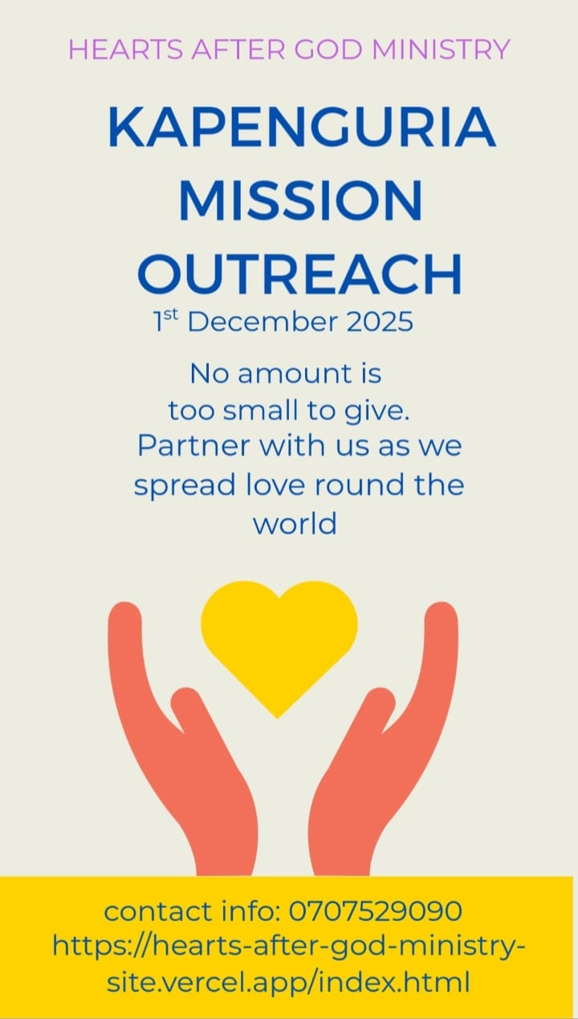

**OUR WEEKLY SERVICES**

|  |  |  |
| --- | --- | --- |
| MONDAY | 8PM-9PM | WORD & PRAYER |
| WEDNESDAY | 8PM-9PM | TONGUES SESSION |
| FRIDAY | 8PM-9PM | BIBLE STUDY |

**DISCIPLESHIP PROGRAMME**

*Galatians 4:19:My dear children, for whom I am again in the pains of childbirth until Christ is formed in you.*

**Co-ordinator: MINISTER CYRILLA CHIKAMAI**

The ministry carries a 14 Day Discipleship programme for new believers who have given their lives to Christ.It also offers accommodating programme for those who have fallen in faith or rather backslided in their journey with God.

*Galatians 6:2:Carry each other’s burdens, and in this way you will fulfill the law of Christ.*

The programme provides automatic certification after completion of the classes.

The services for the programme runs through out the year.

It has a whats app group where the believers meet for the class and prayers session.

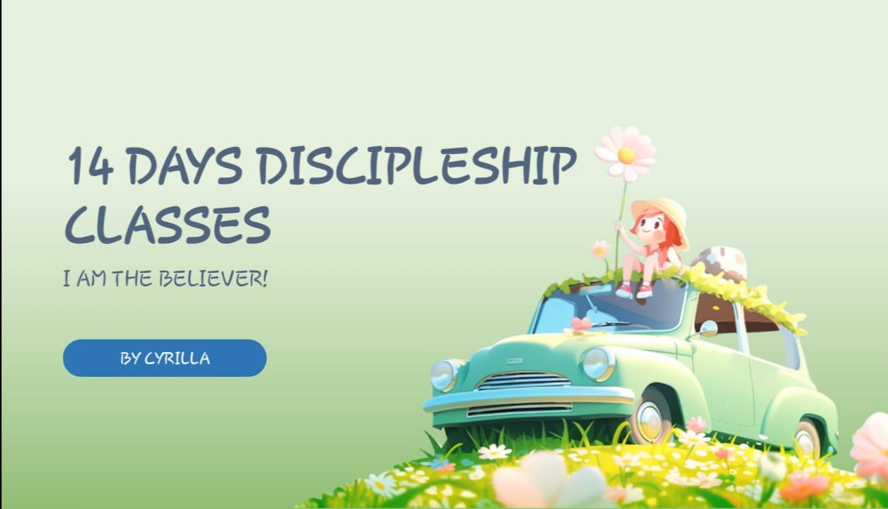

**MEDIA CO-ORDINATOR: MINISTER BONNIFACE ONDUSO**

Through the ministry media co-ordinator the ministry offers a platform for blogs, articles and posters where visual service is provided with aim of creating awareness.The posts are shared across the social media platforms where the links are provided below.

**SOCIAL MEDIA LINKS AND PLATFORMS**

|  |  |  |
| --- | --- | --- |
| **ICON** | **NAME** | **LINKS** |
| Gmail PNG Photo Images (High-Quality) with transparent backgrounds_ You can freely use these Gmail PNG images on your design projects_ | GMAIL | [heartsaftergodministries254@gmail.com](mailto:heartsaftergodministries254@gmail.com) |
| download (1) | WHATS APP | <https://chat.whatsapp.com/F1BIzqQTulA5t5XlUDLWhK> |
| Facebook Logo PNG | FACEBOOK | <https://www.facebook.com/share/g/16NwpW8sCB/> |
| download | INSTAGRAM | <https://www.instagram.com/reel/DK2MTiVCR-k/?igsh=NngyM2p4anFmaG9l> |
| TikTok Classic Circle Logo PNG for Free Download _ TopPNG | TIKTOK | <https://www.tiktok.com/@heartsaftergodmin7?_t=ZM-8x9VO2On7B7&_r=1> |
| Telegram Logo PNG | TELEGRAM | <https://t.me/+ZnRxd1gF7AcwMzY0> |
| SANTOSH RATHVA | YOUTUBE | <https://youtube.com/@heartsaftergodministries?si=psY5wvKqNS_nls95> |
| 14 DAYS DISCIPLESHIP LOGO | DISCIPLESHIP CLASS | <https://chat.whatsapp.com/Cyjm2DDg5Gi08QHDW6Uw5p?mode=r_t> |
| HEARTS AFTER GOD LOGO | MINISTRY WEBSITE | <https://hearts-after-god-ministry-site.vercel.app/index.html> |

FOR PARTNERSHIP PLEASE SEND YOUR INFOR THROUGH :

THE GMAIL MINISTRY ACCOUNT- [heartsaftergodministries254@gmail.com](mailto:heartsaftergodministries254@gmail.com)

CONTACT INFO- 0707529090